Thejasvenan T. 220638J
ME 2261 - Embedded Systems Log Book
Day 13 – 17.10.2025
Task 1
Input character in virtual terminal while LED is blinking in PORT C.
The output for ASCII value of character will turn on at PORT B.
#define F_CPU 8000000UL
#include <avr/io.h>
#include <avr/interrupt.h>
#include <util/delay.h>

void USART_init(void) {
UCSRA = 0x00;
UCSRB = 0x98;
UCSRC = 0x86;
UBRRL = 0x33;
UBRRH = 0x00;
}

ISR(USART_RXC_vect) {
PORTB = UDR;
}

int main(void) {
USART_init();
sei();
DDRB = 0xFF;
DDRC = 0xFF;

while (1) {
PORTC |= (1 << PC0);
_delay_ms(2000);

PORTC &= ~(1 << PC0);
_delay_ms(2000);
}
return 0;
}
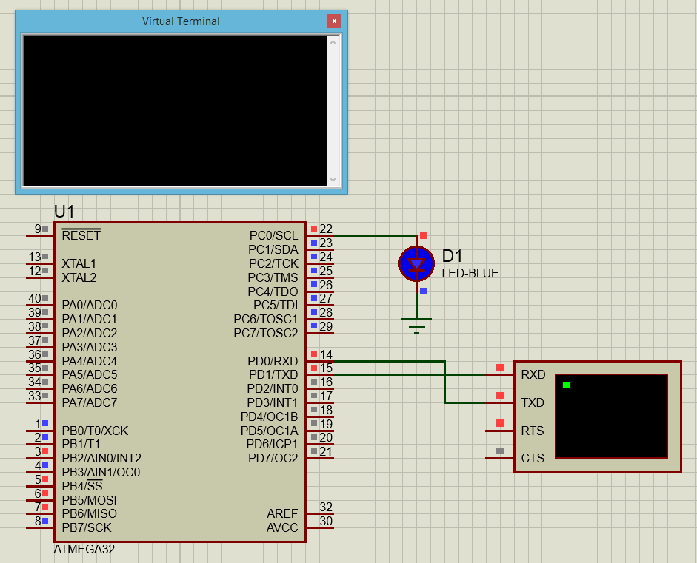

Task 2
There will be a delay in the same task 1 here when we interrupt the same task like this.
#define F_CPU 8000000UL
#include <avr/io.h>
#include <avr/interrupt.h>
#include <util/delay.h>

void USART_init(void) {
UCSRA = 0x00;
UCSRB = 0b00011000;
UCSRC = 0x86;
UBRRL = 0x33;
UBRRH = 0x00;
}

ISR(USART_RXC_vect) {
PORTB = UDR;
}

int main(void) {
USART_init();
sei();
DDRB = 0xFF;
DDRC = 0xff;

while (1) {
while((UCSRA & (1<<RXC)) == 0x00){
PORTC = 0x00000010;
_delay_ms(1000);
PORTC = 0x00000000;
_delay_ms(1000);
}
PORTB = UDR;
_delay_ms(1000);
}
return 0;
}
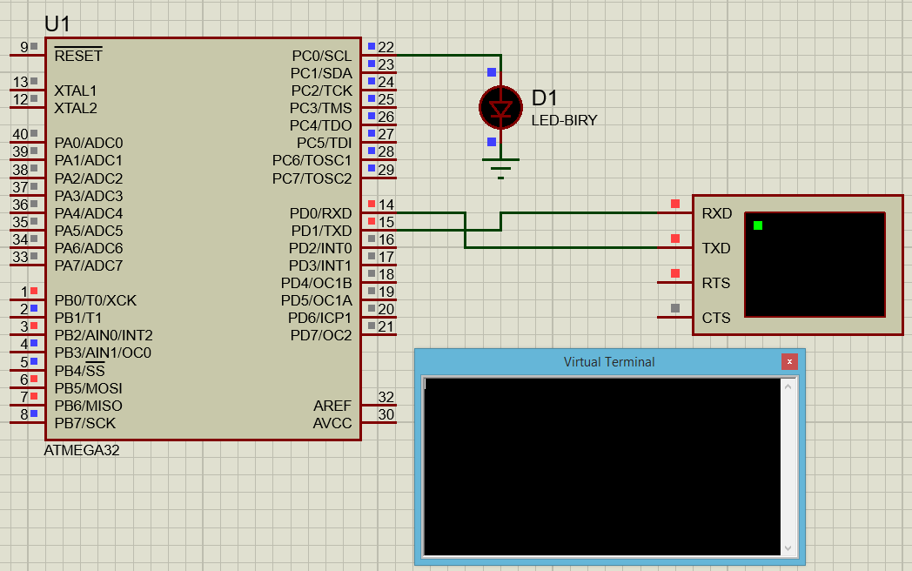
Task 3
When the push button is pressed or released, the PORTB becomes ~PORTB.
#define F_CPU 8000000UL
#include <avr/io.h>
#include <avr/interrupt.h>
#include <util/delay.h>

ISR (INT1_vect)
{
PORTB = (~PORTB);
}

int main(void)
{
GICR = (1<<INT1);
MCUCR = (1<<ISC10);
sei();
DDRB = 0xFF;
DDRC = 0X0;
PORTB = 0b01010101;
while (1){;}
return 0;
}

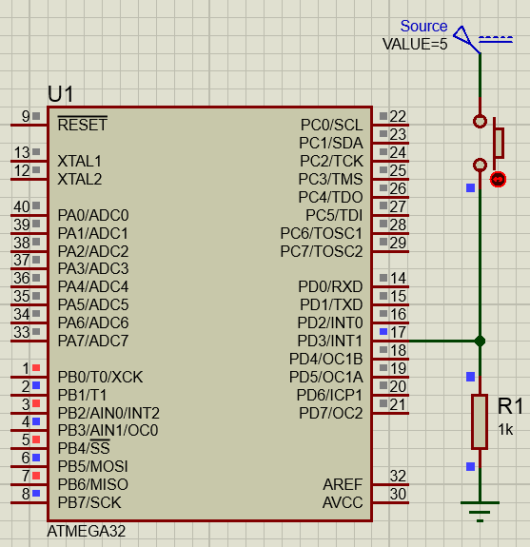

Task 4
When the push button is pressed & released, the PORTB becomes ~PORTB.
#define F_CPU 8000000UL
#include <avr/io.h>
#include <avr/interrupt.h>
#include <util/delay.h>

ISR (INT1_vect)
{
PORTB = (~PORTB);
}

int main(void)
{
GICR = (1<<INT1);
MCUCR = (1<<ISC10) | (1<<ISC11);
sei();
DDRB = 0xFF;
DDRC = 0X0;
PORTB = 0b01010101;
while (1){;}
return 0;
}

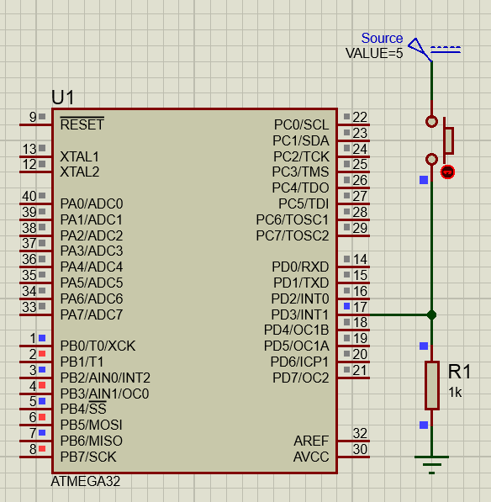

Task 5
Without prescaler
#define F_CPU 1000000UL
#include <avr/io.h>
#include <avr/interrupt.h>
#include <util/delay.h>

void timer0_init()
{
TCCR0 |= (1 <<CS00);
TCNT0 = 0;
}

int main(void){
DDRC |= (1 << 0);
timer0_init();
while(1){
if (TCNT0 >= 249)
{
PORTC ^= (1<<0);
TCNT0 = 0;
}
}
}
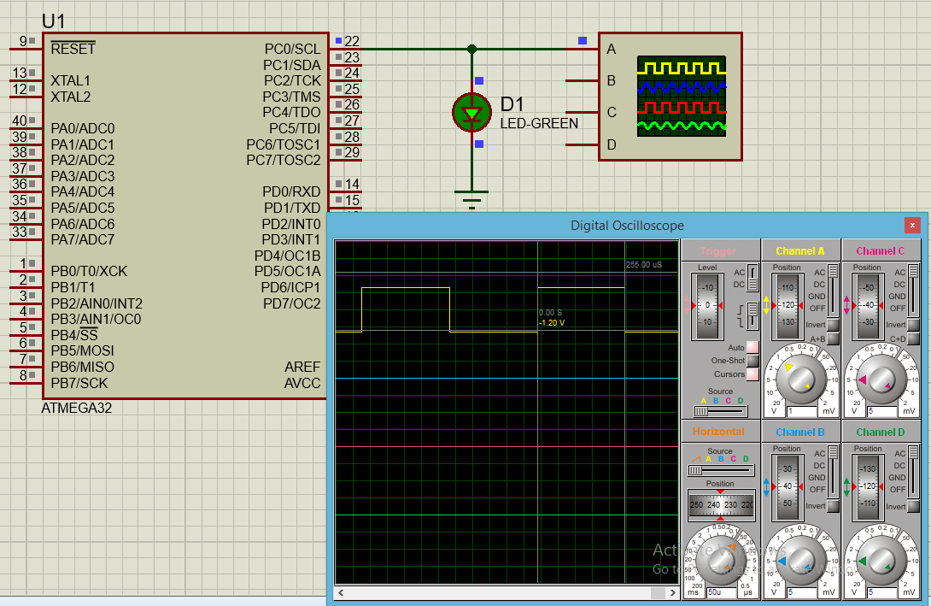

Task 6
Using prescaler
#define F_CPU 10000000UL
#include <avr/io.h>
#include <avr/interrupt.h>
#include <util/delay.h>

void timer0_init()
{
TCCR0 |= (1 <<CS02); // prescaler 256
TCNT0 = 0;
}

int main(void){
DDRC |= (1 << 0);
timer0_init();
while(1){
if (TCNT0 >= 249)
{
PORTC ^= (1<<0);
TCNT0 = 0;
}
}
}

